ANNEX TRANSFERS

Click on Aleph in upper left corner. Make sure your computer is set to:
Connect to FCL01-Prod
Select ADM Library: DEP50-Prod
Make sure you are searching in FCL01 (Bibs).

- Wand in barcode (or search by call#, title, etc. in Browse or Find). In upper right corner, click on to get to bib record.

- Copy OCLC# from record <Control-C>, set search for OCLC in Browse or Find and paste in OCLC# <Control-V> Multiple records may result. Hi-lite the search result line, and hit Show tab (on right side of screen).

- If a DP record exists, use this record! DO NOT create a new bib. for the Annex (FCANN), with the same OCLC# as an existing bib. for the Depository (FCDPT)

- On any DP record showing items already in the Depository, create a separate HOL for materials to be sent to the Annex! This is important, as it eliminates the danger of duplication! Link Annex items to the FCANN HOL! Make sure Depository items are linked to the FCDPT HOL.

- Update and enter the SAME HOLDINGS STATEMENT into both HOLs. The different locations will be reflected in the item list.

- For new materials being sent, change/input the following HOL fields: OWN; 852 0_(with subfield Per for periodicals); 86641, 85656 URL (for periodicals)

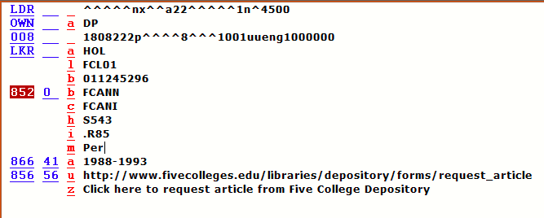

- If no DP record exists: New materials will be sent to the Annex, with one exception: A complete serial volume replacing an incomplete one, after confirming with FCLRC staff.
- If all items on the UM record need to be transferred: Change the own codes to DP on the bib and HOL and use that record. Items need to be relinked in ADM DEP50. Delete the UM ADM.
- If only some items on the UM record need to be transferred: Create a new record for the DP with <Control-N> and click through any “ini” screens that pop up. Add OWN code DP to bib, create HOL and add OWN DP. Add and relink items under ADM DEP50; delete transferred items from the UM record. Adjust holdings statements.

- When all UM items are transferred per a) above, delete any Subscriptions and Orders in the Acquisitions Module before deleting the UM ADM. Exception: If an Order has invoices attached, create new DP record and retain UM record per instructions for b) above. Add a 590 note in the UM HOL: All items transferred to DP, but record cannot be deleted because of attached invoices. Add STA SUPPRESSED to UM bib. Create an artificial UM item with Material Type ADMIN (in drop-down menu).

- EAST commitment example: 583 1 a committed to retain
c 20160630
d 20310630
f EAST
u http://eastlibraries.org/retained-materials
z FC Repository copy: EAST commitment
5 MaAhFCL
- Monos/Serials vs. Periodicals:
- Most Monos and Serials will require status 01 (Regular) in the item. The Depository Collection for these is FCDPM.
- Periodicals will require status 11 (Non-circulating) in the item. The Depository Collection code for these is FCDPS. FCANN will be FCANI for all. Periodicals need the following URL to be inserted into the record:

856 56 u http://www.fivecolleges.edu/libraries/depository/forms/request_article
z Click here to request article from Five College Depository

- Affiliates will require status 13 (Restricted). These are considered to be Periodicals (with Depository collection code FCDPS), and require the URL. If an Affiliate title, insert a 590 _ _ into the HOL as follows:
JSTOR TITLE
PROJECT MUSE TITLE
ACS TITLE (for American Chemical Society)
APA TITLE (for American Psychological Association)
APS TITLE (for American Physical Society)
IOP TITLE (for Institute of Physics)
RSC TITLE (for Royal Society of Chemistry

