# Omeka S End User Documentation:

**Omeka S Documentation Page:** <https://github.com/omeka/omeka-s-enduser>

**Omeka S Admin Interface URL:** <http://exhibits.library.umass.edu/omeka-s/>

# Overview

(For each section on the left column of the Omeka S admin interface on the web)

**RESOURCES**

The “Resources” section is how you access information about the individual items in your exhibit.

**Items**

<https://github.com/omeka/omeka-s-enduser/blob/develop/content/items.md>

* Where you can view all of the items in Omeka S.

**Item Sets**

<https://github.com/omeka/omeka-s-enduser/blob/develop/content/item-sets.md>

* It is important to create an item set for each exhibit, this will help to logically organize all of the items in Omeka into exhibits.
* You can create a new set by clicking on the “Add new item set” button in the upper, right corner of your screen.
* An item set is the best way to group your items for each exhibit and must be defined if you want to allow the display of a gallery for all items in your exhibit.
* When you create a new item set you can add metadata about the item set such as title, description, date, creator and more information link element (which can link to the collection page for the exhibit if applicable).
  + This is helpful to keep track of who curated each exhibit and when.

**Vocabularies**

<https://github.com/omeka/omeka-s-enduser/blob/develop/content/vocabularies.md>

* Lists all of the available vocabularies for metadata records and how Omeka S labels them.

**Resource Templates**

<https://github.com/omeka/omeka-s-enduser/blob/develop/content/resource-template.md>

* This is where you define the metadata elements you want to appear on the item record.
* Exhibit Template 1 is a good example template and can be used to generate basic metadata for an item and an item set.
* In the Resource Template you can:
  + Add and remove metadata elements.
  + Set a Label that displays in place of the element name.
  + Provide a Comment to indicate usage of the element.
  + Select a Data Type, “Default” is the best option as it lets you select any data type value when you are editing the item’s metadata (Text, Omeka Resource, URI).
* You can also drag and drop the elements into whatever order you want, and this is the order that they will display on the item metadata record.

**SITES**

<https://github.com/omeka/omeka-s-enduser/blob/develop/sites/sites.md>

* Each exhibit is a site. You can access the Sites options by clicking on “Sites” above the “RESOURCES” section.
* NOTE: You will have to have a site already created.
* You can click on the website you would like to edit and the menu should change on the left-side of the screen to a variety of site options.

**Pages**   
<https://github.com/omeka/omeka-s-enduser/blob/develop/sites/site_pages.md>

* This is where you create pages for you exhibit.
* Each page can have a variety of content blocks, the most useful are:
  + Item showcase: this allows you to select items from the item set you defined for your exhibit and add a caption.
    - This displays as a gallery and if you have a gallery theme selected a modal lightbox is overlaid when a visitor clicks on an item image.
  + Media: when you select this content block you can select an item from the item set you define for your exhibit and add the item as an image of varying sizes and alignment on the page.
  + HTML: this is where you can copy and paste text that you have written for the exhibit.
    - It’s best to break the HTML text into several blocks and insert media blocks in between for the text to wrap nicely.
  + See “CREATING AN EXHIBIT > Adding pages to your exhibit” (step 10) section for more information

**Navigation**

<https://github.com/omeka/omeka-s-enduser/blob/develop/sites/site_navigation.md>

* This is where you set the order and hierarchy of your exhibit pages.
* This is also where you can add a Browse page – this can server a gallery for all items in your exhibit.

**Resources**

<https://github.com/omeka/omeka-s-enduser/blob/develop/sites/site_resources.md>

* This is where you define the items that will be in your exhibit and therefore displayed on your site.

**Theme**

<https://github.com/omeka/omeka-s-enduser/blob/develop/sites/site_theme.md>

* There are three central themes.
* Each of these themes is duplicated to include a modal lightbox feature that is overlaid upon the item-showcase content block. This is indicated by the “with Gallery” label.
* The Horizontal and Vertical labels refer to the direction of the navigation bar.
* Simple is great for mobile devices and meant to be simple and unique from the Vertical and Horizontal layout styles.

**Settings**

* You can select where title links will link to, the best option is Item page (which is the item metadata record).
* This is also where you can select whether you would like to display social media buttons: Facebook, Twitter, Tumblr, Pinterest, Email, Embed codes and where those buttons will display on the page: Top or Bottom.

**CREATING AN EXHIBIT**

1. Create a new Item Set for the exhibit

<https://github.com/omeka/omeka-s-enduser/blob/develop/content/item-sets.md>

* 1. Click on “Item Sets” under the RESOURCES section.
  2. Click “Add new item set” in the upper, right corner of your screen.
  3. Select Resource Template: Exhibit Template 1.
  4. Leave Class empty because you want to be able to set the class on the item level later when you are importing items.
  5. Fill in appropriate Dublin Core fields:
     1. Title (you can title the item set to be the same as the exhibit title – or a shortened version of it)
     2. Description
     3. Date you created the exhibit
     4. Creator (you)
     5. Collection (s)
     6. Identifier is required: add a unique identifier for the exhibit; this can be the items’ collection identifier.
        1. Just click “Add Value” to add more than one identifier if you have items from multiple collections.
     7. More Info (can be a link to any other info on the exhibit like the collection page).
  6. See screen shot below as an example:  
       
       
       
       
       
       
       
       
       
       
       
       
     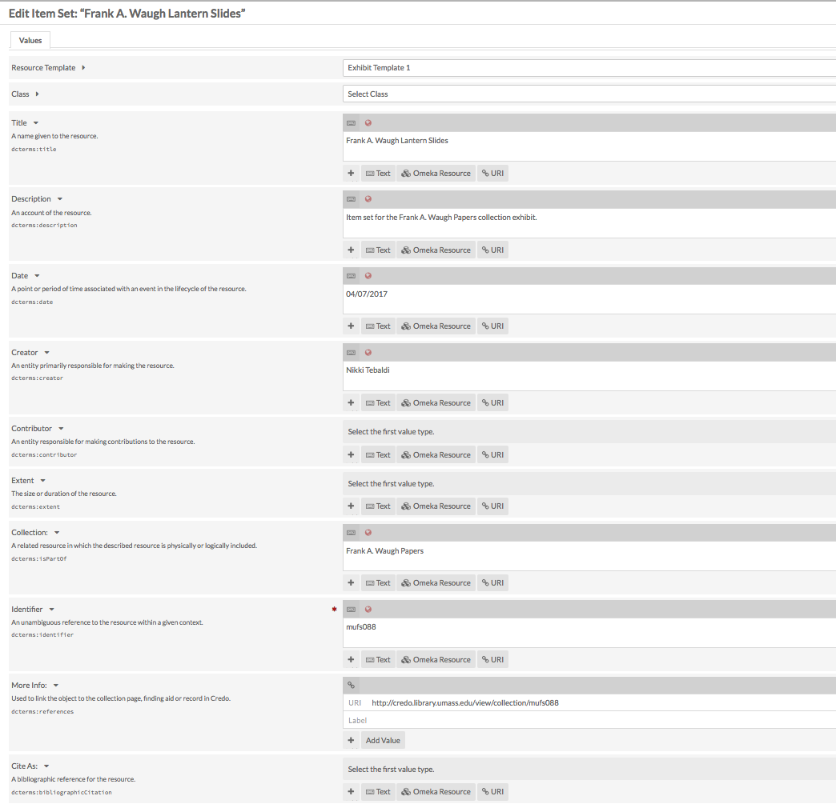

1. Enter item metadata into Template CSV – see “import-example.csv” as an example.
   1. If you want to figure out how to label the metadata elements in the CSV file (the columns) so that they will auto-map, take a look at “Vocabularies” and click on the “Properties” number for the vocabulary elements’ titles.
   2. NOTE: The Item Set column should have the Item Set’s ID number which can be found by going to the Item Set page (clicking on “Item Sets” and then clicking on the Item Set to see the record for it) and then looking at the URL:
      1. There should be a number at the end of the URL and that is the ID number for the item set and the value for the Item Set column.

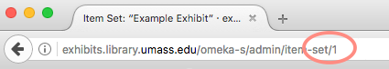

1. Click on “CSV Import.”
   1. “Browse…” for the CSV file you edited.
   2. Import type should be set to “Items.”
2. Click “Next.”
3. Click “Map to Omeka S Data.”
   1. Most of the metadata elements should auto map from the CSV column labels except for:
      1. Template – click Item data – click Resource Template Name.
      2. dctype – click Item data – click Resource Class Term.
         1. Determined by looking at “Vocabularies” – Dublin Core Type – Term.
      3. dcterms:references – click on Properties and select “Import as URL reference” (this will set this property value to be a link).
      4. Item Set –click Item data – click Item Set ID.
      5. file1 through file5 – click Media Import – click URL (URL should be used for all file imports).
      6. See screenshot below as an example:

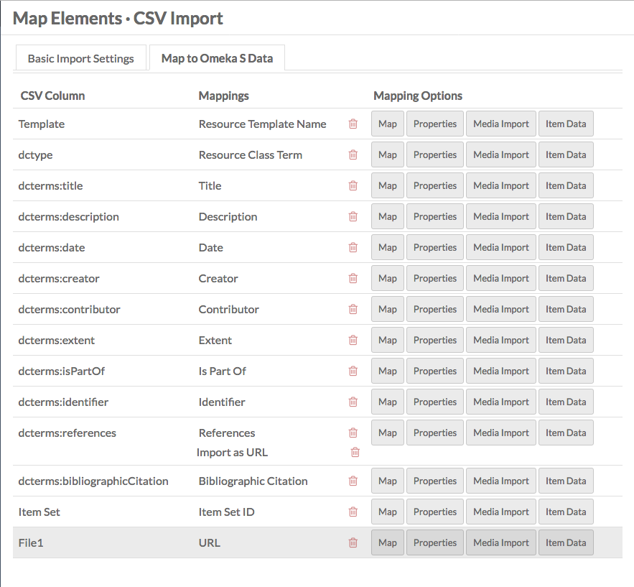

1. Click Import.
2. Wait for import to complete.
3. Create a new site  
   <https://github.com/omeka/omeka-s-enduser/blob/develop/sites/sites.md>
   1. Click on “Sites” and then Add new site.
   2. Enter a title.
   3. Enter URL slug – (shortened version of the title with hyphens used for spaces).
   4. Click on the “Theme” tab:
      1. There are six themes total, but there are three main themes:
         1. “Horizontal” and “Vertical” refer to the navigation types.
         2. “with Gallery” refers to a modal lightbox option that is coded to be a part of the Item Showcase content block and the Browse navigation page.
         3. Simple allows you to select a primary and secondary colors for the site and works particularly well with mobile devices.
         4. NOTE: You can change a site’s theme at any time.
   5. Click on the “Item Pool” tab:
      1. Under “Search by item set,” Select the item set you created in Step 1 as the item pool for the site.
   6. Click the “Add” button in the upper, right corner.
4. Edit initial site settings.
   1. Click on “Resources”:
      1. Make sure you define the Item Pool.
      2. In the “Item Pool” tab:
         1. Go to “Search by item set” and select the Item Set you created for the exhibit. See below:

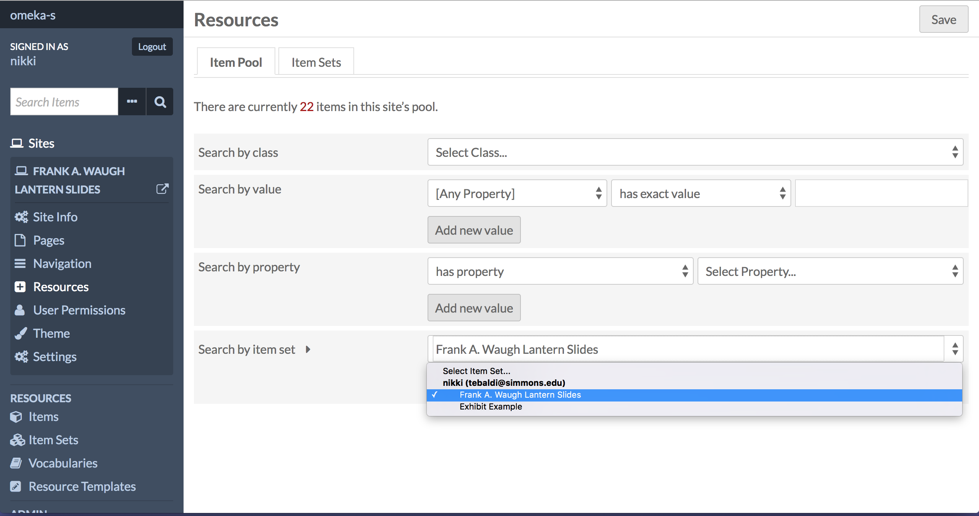

* 1. Click on the “Item Sets” tab and click on your user name under “ALL ITEM SETS”
     1. Click on the name of the item set you want to use and it should show up listed in the center of the page.
     2. See below:

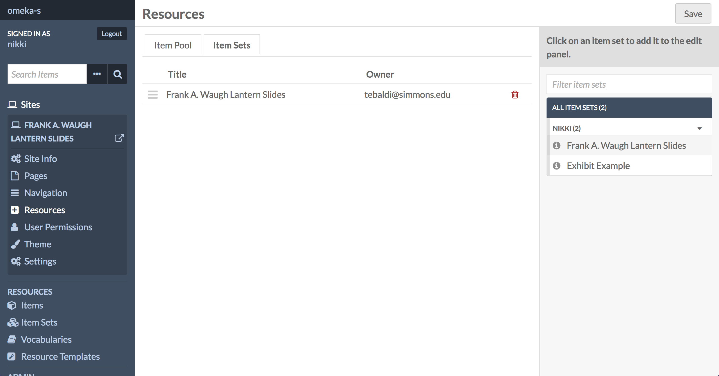

* 1. Go to Settings:
     1. Attachment link type should go to Item page which is the metadata record for the digital object (this will cause all titles displayed in the exhibit to link to the record, which then links to the collection page, finding aid or object in Credo).
     2. You can select a variety of Sharing options and location of sharing buttons as well.

1. Adding pages to your exhibit.
   1. Click on “Pages” under the Sites section.
   2. The default is to create a welcome page, you can edit this page or delete it based on your preference.
   3. Create a new page  
      <https://github.com/omeka/omeka-s-enduser/blob/develop/sites/site_pages.md>
      1. Click “Add new page” in the upper, right corner of your screen.
      2. Enter a title and URL slug (keep this short and use hyphens for spaces).
   4. Add content blocks based on your exhibit needs, the most helpful are:
      1. **Item Showcase**: Functions as an exhibit gallery; you have to add all items as attachments individually.
         1. This also will have a gallery modal lightbox overlaid on it if you selected a theme with a gallery label.
         2. The thumbnail size that displays the best is square, but you can select medium or large to display as well; this does not matter for video and audio because Omeka uses graphic icons as thumbnails for these file types
         3. You can also use the Item Showcase block to display one item in the center of your page.
         4. NOTE: To display a video with text use the Media content block; item showcase displays the automatically generated thumbnails which is currently not working for video.
         5. **This content block has been modified to meet our needs and includes a modal lightbox, so Omeka’s end user documentation will differ slightly but is still applicable.**
      2. **HTML**: a good block to use to paste in text for the exhibit.
      3. **Media**: content block allows you to display an item on your site’s page. You can define thumbnail type (size), alignment (on the page), and whether a title is shown.
         1. NOTE: For video, the width of the thumbnail will always be 650 pixels and will scale down for mobile responsivity.
      4. **Line Break**: is helpful if you want to break up text and media or not have text wrap around media.
      5. You can add as many content blocks as you want on each page, for example you can add an HTML content block to copy and paste text into and then add a Media block and define its alignment and then add another HTML block and the text will wrap around the media block based on the media block’s alignment.
      6. See Omeka S documentation for detailed information on content blocks.
2. Editing site navigation  
   <https://github.com/omeka/omeka-s-enduser/blob/develop/sites/site_navigation.md>
   1. Click on Navigation.
   2. By default, the Browse page is present, you can delete this page or use it to show all of the exhibits items (see Browse section below).
   3. Add the pages you created by clicking the plus sign to the right of the page title.
   4. You can drag and drop the site pages into the order you want them to display.
3. Adding a browse page (Optional):
   1. This is helpful if you want to display all of the items in your exhibit. This is based on the item set you created for the exhibit.
   2. Click on “Browse” under the “Add a custom link” section in the Navigation section.
   3. Click on the pencil icon to edit the Browse page.
   4. Name the page what you would like by filling in the “Label” field.
   5. Leave the “Query” field blank.
   6. NOTE: For all items to display in your exhibit you must define the Item Pool to be the Item Set you created for the exhibit. This is in the Resources section of the Sites section (see Step 9).

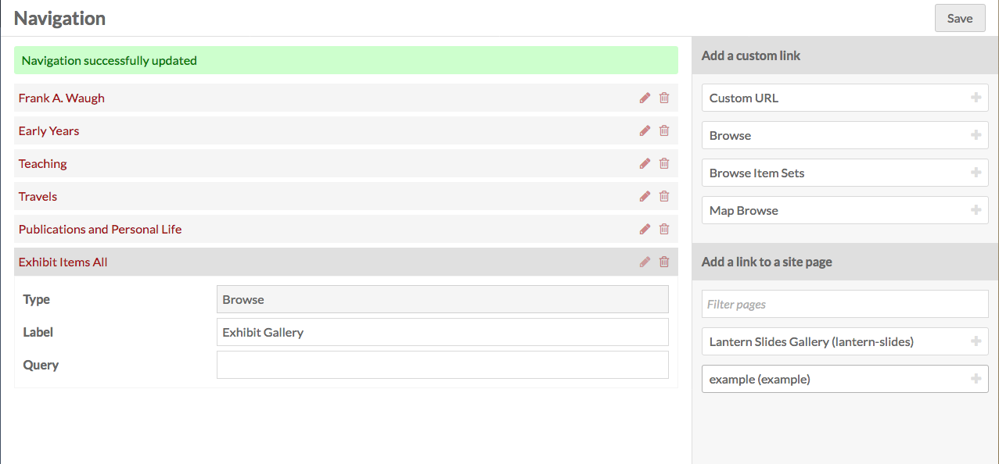

1. Adding a logo

<https://github.com/omeka/omeka-s-enduser/blob/develop/sites/site_themesettings.md>

* 1. NOTE: If you do not add a logo the site title will appear in all capitals at the top of every page.
  2. Your logo should be 1150px by 200px by 72px (resolution).
  3. Click on “Theme.”
  4. Click on “Edit theme settings” for the active theme.
  5. Under Logo, click “Select.”
  6. Click “Browse,” browse to find your logo file.
  7. Click “Upload.”
  8. Click on the logo image from the list labeled Select Asset.
  9. Click “Save” to save the theme settings.

1. Editing the Footer Content   
   <https://github.com/omeka/omeka-s-enduser/blob/develop/sites/site_themesettings.md>
   1. By default the footer will display SCUA’s logo, name and will link to SCUA’s homepage.
   2. To change this click on Theme and edit the Footer Content field.
   3. Click “Save” to save the theme settings.
2. Further customization: The “Simple” layout lets you define color accents <https://github.com/omeka/omeka-s-enduser/blob/develop/sites/site_themesettings.md>
   1. Select one of the “Simple” layouts as your theme.
   2. Click on Edit theme settings.
   3. Define a hex color code for the main accent color (links) and the navigation background color.
3. Making a site public
   1. Click on the Site so that you have access to edit (Click “Sites” > click on the sites name > click “Site Info”)
   2. In the upper, right corner of your browser you should see an eye icon, click this icon to make the site public.
   3. Click “Save” to save the site settings.
   4. See screenshot for location of the icon:

